
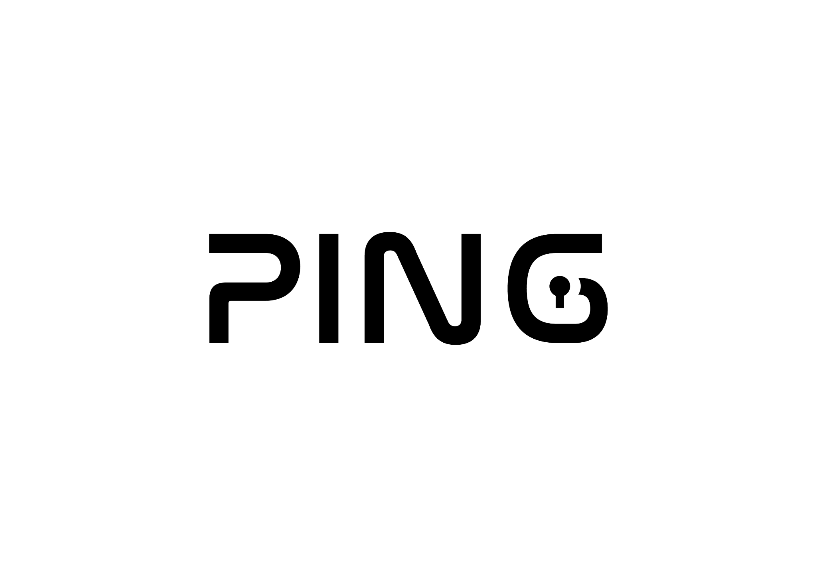
PENETRATION TESTING RESEARCH REPORT
USB Rubber Ducky 3.0 - Browser Data Exfiltration via HID Injection PowerShell Staged Payload Attack

21 APRIL 2026
AUTHOR: SZYMON STEFAŃSKI
CLASSIFICATION: EDUCATIONAL RESEARCH FOR KN PING
ENVIROMENT: CONTROLLED ISOLATED LAB
VERSION: 2.0

Statement Of Confidentiality
The contents of this document have been developed by Szymon Stefański, during research work and testing of one of the tools produced by Hak5 company called “Rubber Ducky USB”. Information included in this report is considered to be used ONLY for educational purposes and performance of its intended use.
All the contents of this document that will be used outside of its legal purposes and educational functions will be considered an act of illegal actions, that the author does not take responsibility for.

Contents
Statement Of Confidentiality 1
Executive Summary 3
Research Objectives 3
Scope 3
Assessment Overview 4
Browser Data Breach Penetration Test assessment Summary 4
Summary Of Findings 4
Attack Architecture Overview 4
File Structure 5
Attack Flow Diagram 6
Testing Summary 6
Remediation Summary 7
References 7

Executive Summary
This research demonstrates a physical attack vector on Windows 11 workstation using the Hak5 USB Rubber Ducky 3.0 (USB-C) to exfiltrate session data, cookies, passwords and browsing history from multiple installed browsers without requiring any network connectivity on the target machine.
The attack leverages a two-stage payload architecture: a DuckyScript "Stager" that launches a PowerShell "Stage" script from the device's onboard storage. Testing revealed that while Windows Defender's Tamper Protection successfully prevented direct security policy modification, the combination of folder exclusions and native tool abuse ("Living off the Land") allowed complete extraction of encrypted browser databases. The total attack time from USB insertion to data exfiltration was approximately 15–25 seconds.

Research Objectives
The primary objectives of this research were to understand the mechanics behind Hak5 Rubber Ducky 3.0 USB as both HID device and mass storage simultaneously, surpass the Ducky’s typing speed limitations, that affected the payload’s efficiency, identify and document the specific Windows 11 security layers that can be bypassed and to understand the limitations of physical attack tools in hardened environment.

Scope
Attack Device | Hak5 USB Rubber Ducky 3.0 (USB-C)
Target OS | Windows 11 Pro (Fully Updated, June 2025)
Target Security | Windows Defender (Real-Time + Tamper Protection Enabled)
Target Browsers | Opera GX, Google Chrome, Microsoft Edge and other browsers
User Privilege Level | Local Administrator
Network | Offline (No internet required)
Lab Type | Isolated, controlled research environment
Additional Attack Tools | HackBroswerData v0.4.6 win64x version

Assessment Overview
During the initial penetration test against the target machine’s Windows Defender, I found a few issues encountered both on the target machine and while working with the Rubber Ducky USB device.
After resolving the issues with ducky, I managed to walk around Windows Defender functionality to perform a successful attack and retrieve browsers data using a tool named HackBrowserData, created by moonD4rk on GitHub.

Browser Data Breach Penetration Test assessment Summary
Target machine treated Rubber Ducky USB as a HID device, allowing it to perform as a stager tool, running scripts in trusted places of a system, before Windows Defender could block its actions.

Summary Of Findings
- Physical USB access enabled complete attack execution in approximately 15-25 seconds.
- Windows Defender's Tamper Protection successfully prevented direct security policy modification, even with local Administrator privileges.
- A "Race Condition Window" of approximately 10-15 seconds exists between adding a folder exclusion and Defender's post-process behavioral scan, during which a known tool can execute successfully.
- "Living off the Land" techniques (robocopy, native PowerShell commands) were never flagged or blocked by any security layer during testing.
- Browser password decryption failed due to a DPAPI (Data Protection API) context mismatch between the Administrator process and the standard user's cryptographic vault. However, the rest of the data stayed intact and accessible.
- Separating the attack into a "Stager" (DuckyScript) and a "Stage" (PowerShell .ps1 file) completely eliminated keyboard input buffer overflow errors that plagued single-script approaches.

Attack Architecture Overview
The attack uses a two-phase "Staged" architecture. This separates the delivery mechanism from the payload logic, which eliminates the keyboard buffer overflow problems associated with long single-script approaches.

File Structure
MicroSD Root/
- inject.bin
- run.ps1
- tools/
  - h.exe
The decision to separate the attack process into two files, one with DuckyScript and second with PowerShell script was made to eliminate any issues with buffer overflow. Ducky’s speed is so high, that Windows is not capable of processing it all and adding delays and lowering typing speed slows everything down and limits the actions that can be taken.

Attack Flow Diagram
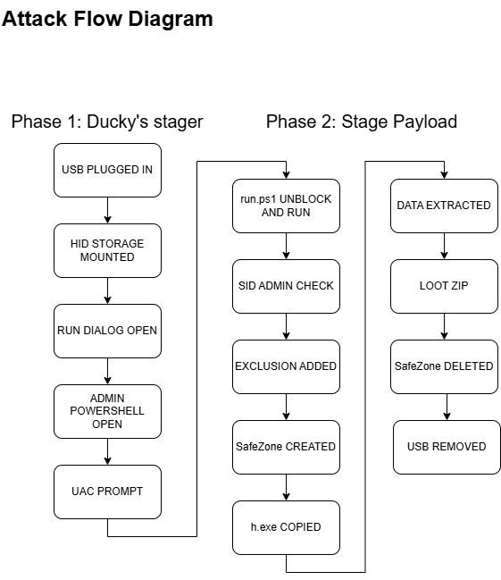

Testing Summary
Ducky was detected as a keyboard instantly. It was able to open its mass storage and run “Stager” script to open PowerShell in hidden mode with execution policy bypass as well as unblock and run run.ps1 file. PowerShell was successfully open with administrator privileges allowing it to exclude the SafeZone folder with copied h.exe file, allowing that program to stay alive during data extraction. Browser data was extracted, only with passwords remaining encrypted, due to DPAPI mechanisms. Evidence ( SafeZone ) was deleted, history was not being saved and loot has been transferred to zip file and saved on Ducky’s mass storage. The total process took between 15 – 25 seconds.

Remediation Summary
Defense | Effectiveness | Method
Disable USB ports | High | Group Policies
USB Device Whitelisting | High | Intune/GPO
Tamper Protection | Med | Default Windows Settings
Constrained Lang. Mode | Med | AppLocker
Disable PowerShell (users) | High | GPO
User Privileges Control | Med | Privileges Control
EDR With USB Monitoring | Med | CrowdStrike
Screen Lock | Med | GPO

References
- Hak5 - Rubber Ducky Documentation
https://docs.hak5.org/hak5-usb-rubber-ducky
- HackBrowserData - GitHub Repository
https://github.com/moonD4rk/HackBrowserData
- MITRE ATT&CK ( Input Injection )
https://attack.mitre.org/techniques/T1674/
- Microsoft - Windows DPAPI Documentation
https://learn.microsoft.com/en-us/windows/win32/secdp/data-protection-api
- Microsoft - Tamper Protection Documentation
https://learn.microsoft.com/en-us/microsoft-365/security/defender-endpoint/prevent-changes-to-security-settings-with-tamper-protection
- Microsoft - Win32_Volume WMI Class
https://learn.microsoft.com/en-us/windows/win32/cimwin32prov/win32-volume

